Letter from JM to Prodi

EU – Russia Relations

I am attaching a joint letter from the President of the Federation of Independent Russian Trade Unions (FNPR), Mr Michael Shmakov, and myself, addressed to you and to the President of the Russian Federation making some proposals to give a social dimension to the EU – Russia relationship.

Mr Shmakov will be raising the issues with Mr Putin tomorrow, and we intend to publicise this approach.

We hope that you will be able to give this initiative a positive welcome, and perhaps refer to it in the conclusions of the forthcoming EU – Russia Summit.

With best wishes

Yours sincerely

John Monks

enc.

  EUROPEAN TRADE UNION  CONFEDERATION - ETUC (CES) | 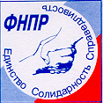  FEDERATION OF INDEPENDENT  TRADE UNIONS OF RUSSIA - FNPR

Brussels, 6 May 2004
JM/TJ/cd

To the attention of: To the attention of:

Romano Prodi Vladimir V. Putin
President President of the Russian Federation
European Commission
Avenue d’Auderghem, 45 Kremlin, Moscow

B - 1040 BRUSSELS RUSSIAN FEDERATION

Re: relations between the Russian Federation and the European Union

Dear President Prodi,
Dear President Putin,

The FNPR and the ETUC have been following the development of relations between the Russian Federation and the European Union with close interest and welcome the agreement on 27 April to extend the Partnership and Cooperation Agreement to the enlarged EU. We fully subscribe to the commitment of the EU and Russia to ensure that EU enlargement will bring them closer together in a Europe without dividing lines. We write today to express our will to contribute to this objective.

We believe that the development of the EU-Russia Common European Economic Space requires a social dimension and the involvement of the social partners along the lines of initiatives taken by the EU with other partners and adapted to particular circumstances, for example in the EEA, the Euro-Mediterranean Partnership, in the context of the Cotonou Agreement, Mercosur, the Trans-Atlantic Dialogue, and the Asia-Europe Meetings. The FNPR and ETUC affiliates have been taking part, and are intending to continue to do so in the future, in activities around the Northern Dimension of the EU policies and “Plans of Action”, as well as in connection with programmes of Baltic and Barents Seas co-operation.

We also note the high degree of recognition extended by the EU and Russian authorities to the Russia-EU Industrialists’ Round Table and the European Business Club in Moscow and would wish for an equivalent relationship to be extended to the Trade Union organisations we represent. An impetus for that approach was given at the 2001 EU-Russia Summit, but this appears to have faltered. The Report of the High Level Group on the CEES to the 10th Summit in November 2002 stated that ‘The HLG welcomes statements of interest from the business community as well as representatives of civil society and intends to solicit input from such bodies by spring 2003.’ However, there has been no follow-up with the ETUC and FNPR.

In concrete terms, we should be grateful if you would consider the facilitation of:

- a formal exchange of views between ourselves and the Presidency of EU-Russia Summits;
- periodic meetings of the Labour and Social Affairs Minister and Commissioner of both sides, with the opportunity of an input by the social partners; and
- the establishment of permanent consultative arrangements for the social partners on issues of economic and social interest.

The ETUC and FNPR believe that a real Social Dialogue should become a constitutive element of EU-Russia relations and would make a positive contribution to their development. We hope that you will be able to respond positively to our proposals.

Yours sincerely

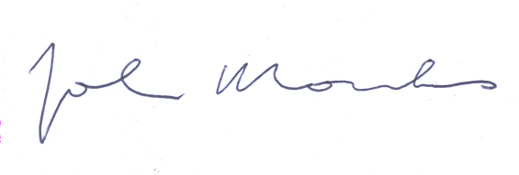 | 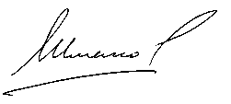
John Monks  General Secretary ETUC | Michael Shmakov  President FNPR

